**Experiment 4**

Name: Kaushal Banthia

Roll Number: 19CS10039

Course Name: Introduction to Electronic Laboratory Course Number: (EC29003)

**Aim:** Studies on Small Signal CE-Amplifier

**Theory:** We can use Bipolar Junction Transistors as Amplifiers for Small Signals. This is done by biasing the circuit. While biasing, we need to ensure that the BJT is operating well within its Active Region and not the Saturation Region or the Cut-off Region. For this purpose, we find its Quiescent Operating Point (Q-Point) and try to make it operate at that point. If this is not taken care of, the output signal will get clipped.

Also, the signal should be a small signal, else it might overshoot into the Saturation Region or the Cut-off Region, even though it is operating at its Q-Point. A small signal has a very small maximum voltage.

The circuit diagram for the BJT as an Amplifier is below.

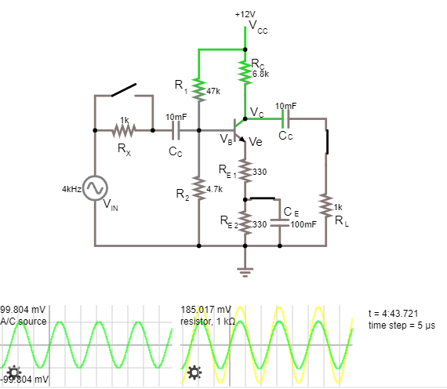

**CIRCUIT 1**

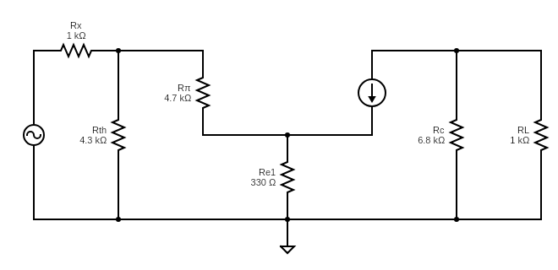The small signal equivalent AC circuit (Pi model) is



$$βI_{B}$$

$I_{in}$

$$V_{in}$$

100 mV

4 kH

**CIRCUIT 2**

|  |  |  |  |  |
| --- | --- | --- | --- | --- |
|  |  | )  (In kΩ)  Theoretical | $$R_{in}$$ $$=V_{in}/I_{in}-R_{x}$$ (In kΩ)  Observed | $$R_{out}$$ = $R_{C}$ (In kΩ) |
| 8.963 | 1.854 | 3.841 | 3.844 | 6.8 |

**Procedure:**

Simulation in VLabs:

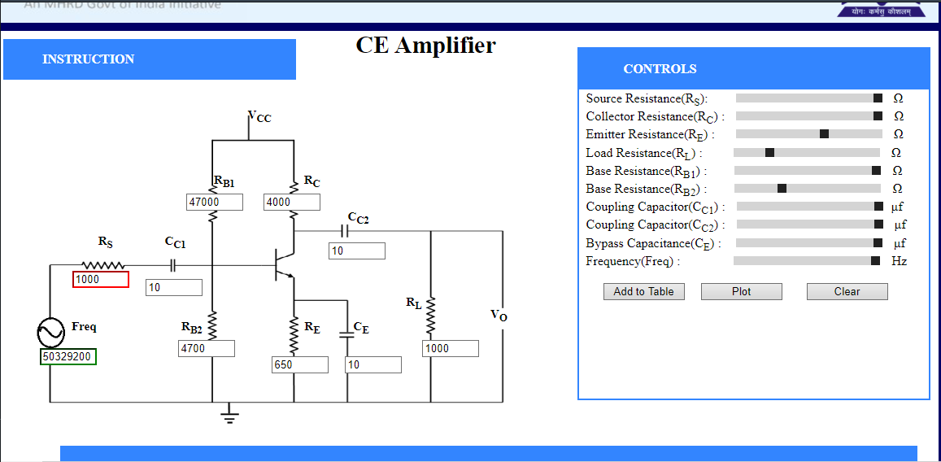

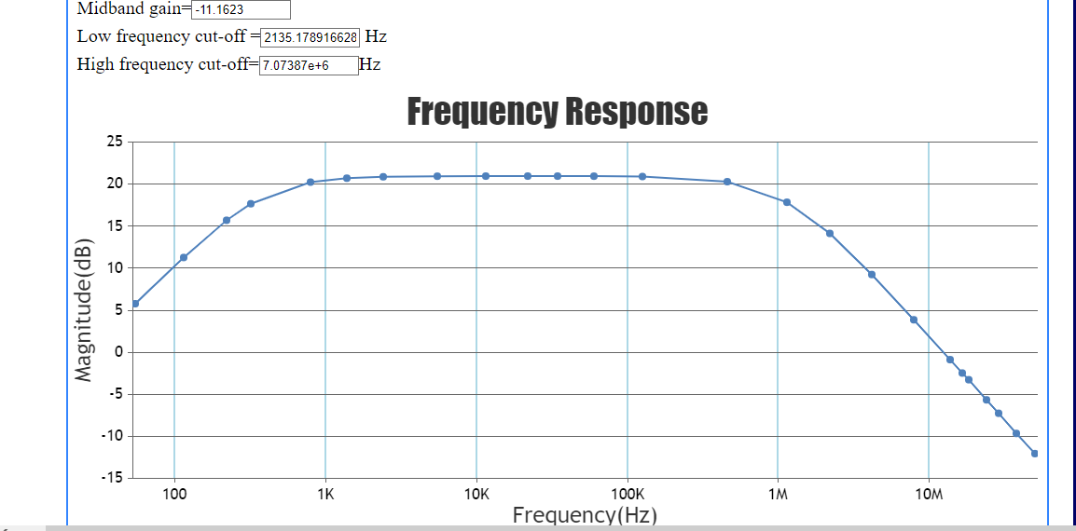

Simulation in Falstad:

1. Measurement of DC Conditions:

|  |  |  |  |  |  |  |
| --- | --- | --- | --- | --- | --- | --- |
| $$V_{B}$$ (in V) | $$V_{C}$$ (in V) | $$V_{E}$$ (in V) | $$V_{BE}$$ $$=V_{B}-V_{E}$$ (in V) | $$V_{CE}$$ $$=V_{C}-V_{E}$$ (in V) | $$I_{C}$$ $$=\frac{12-V_{C}}{R_{C}}$$ (in mA) | $$I_{E}$$ $$=\frac{1+β}{β}I_{C}$$ (in mA) |
| 1.061 | 7.167 | 0.474 | 0.587 | 6.693 | 0.746 | 0.753 |

To verify that the transistor is in its active region, we ensure that the emitter junction is forward biased and the collector junction is reverse biased, i.e., $V_{BE}>0 \& V_{CB}>0$

Here we have $V_{BE}=0.824 V>0 \& V_{CB}=6.693 V>0$

1. Measurement of Signal Handling Capacity:
2. With $R_{L}$ Disconnected

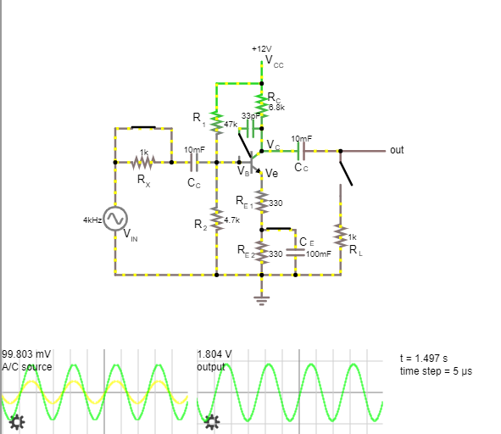

**CIRCUIT 3**

|  |  |  |
| --- | --- | --- |
| Input Voltage (Amplitude) $$V_{in}$$ (in V) | Output Voltage  (Amplitude) $$\frac{V_{out, max}-V_{out, min}}{2}$$ (in V) | Observed gain $$\frac{V_{out}}{V_{in}}$$ |
| 0.1 | 1.828 | 18.28 |
| 0.15 | 2.725 | 18.16 |
| 0.2 | 3.595 | 17.97 |
| 0.25 | 4.413 | 17.65 |
| 0.3 | 5.132 | 17.11 |
| 0.35  (Here the output just starts getting clipped) | 5.528 | 15.79 |
| 0.4  (The clipping gets more evident) | 5.551 | 13.88 |
| 0.45  (The clipping is very much evident) | 5.555 | 12.34 |
| 0.5  (The clipping is very much evident) | 5.555 | 11.11 |

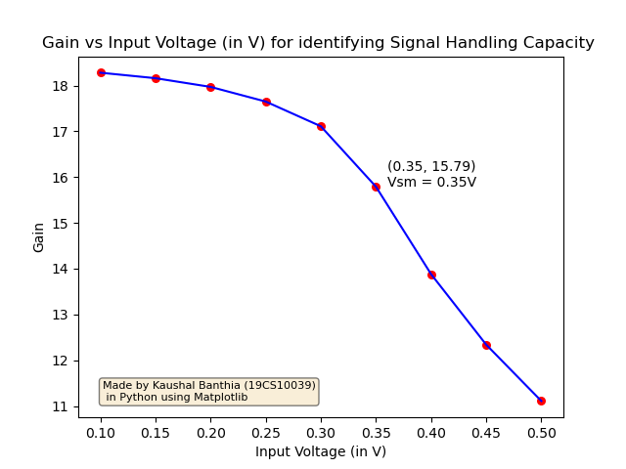

From the above table and the graph, it is quite evident that the Signal Handling Capacity of the Transistor ${(V}_{SM})$ is around 0.35 V (with $R_{L}$ disconnected). That is when the input voltage starts deviating from being a small signal.

**(ii)** With $R_{L}$ Connected 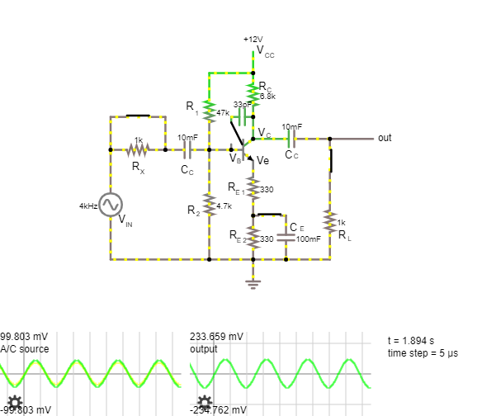

**CIRCUIT 4**

|  |  |  |
| --- | --- | --- |
| Input Voltage (Amplitude) $$V_{in}$$ (in V) | Output Voltage  (Amplitude) $$\frac{V_{out, max}-V_{out, min}}{2}$$ (in V) | Observed gain $$\frac{V_{out}}{V_{in}}$$ |
| 0.1 | 0.234 | 2.34 |
| 0.15 | 0.349 | 2.33 |
| 0.2 | 0.461 | 2.31 |
| 0.25 | 0.565 | 2.26 |
| 0.3  (Here the output just starts getting clipped) | 0.657 | 2.19 |
| 0.35  (Here the output is getting a little clipped) | 0.732 | 2.09 |
| 0.4  (The clipping gets more evident) | 0.798 | 2.00 |
| 0.45  (The clipping is very much evident) | 0.861 | 1.91 |
| 0.5  (The clipping is very much evident) | 0.924 | 1.85 |

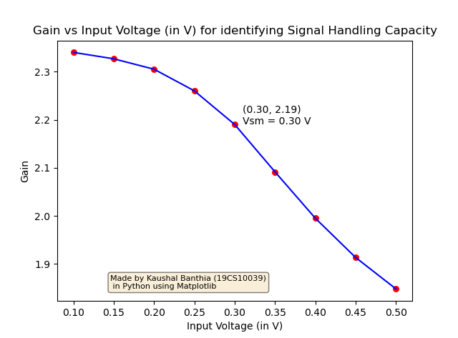

From the above table and the graph, it is quite evident that the Signal Handling Capacity of the Transistor ${(V}_{SM})$ is around 0.30 V (with $R_{L}$ connected). That is when the input voltage starts deviating from being a small signal.

**Conclusion:**

From the above process, we now know that the signal handling capacity for this BJT Amplifier is 0.30 V and also that it decreases a little bit on connecting the load. What also changes, is the output voltage and thus the corresponding gain, which decreases if the load is added.

1. Measurement of Frequency Response:
2. $R_{L}$ Connected

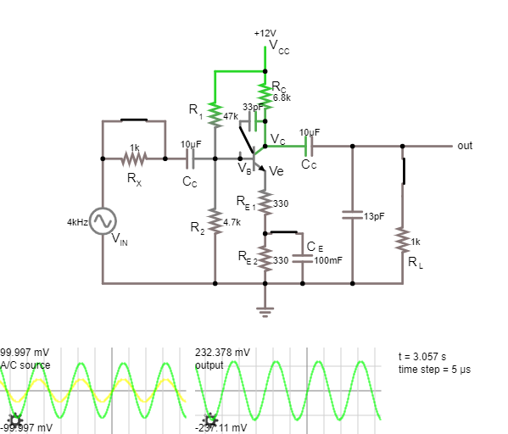

**CIRCUIT 5**

|  |  |  |  |
| --- | --- | --- | --- |
| $$V_{in}$$ (in V) | $$V_{out}$$ (in V) | Frequency  (in Hz) | $$20*log⁡(\frac{V_{out}}{V_{in}})$$ (in dB) |
| 0.1 | 0.116 | 3 | 1.289 |
| 0.1 | 0.147 | 4 | 3.346 |
| 0.1 | 0.211 | 10 | 6.486 |
| 0.1 | 0.223 | 15 | 6.966 |
| 0.1 | 0.231 | 50 | 7.272 |
| 0.1 | 0.232 | 200 | 7.310 |
| 0.1 | 0.232 | 800 | 7.310 |
| 0.1 | 0.232 | 10k | 7.310 |
| 0.1 | 0.232 | 100k | 7.310 |
| 0.1 | 0.231 | 1M | 7.272 |
| 0.1 | 0.230 | 2M | 7.235 |
| 0.1 | 0.224 | 4M | 7.005 |
| 0.1 | 0.208 | 7M | 6.361 |
| 0.1 | 0.189 | 10M | 5.529 |
| 0.1 | 0.176 | 12M | 4.910 |
| 0.1 | 0.164 | 14M | 4.297 |
| 0.1 | 0.149 | 16M | 3.464 |
| 0.1 | 0.142 | 18M | 3.046 |
| 0.1 | 0.112 | 25M | 0.984 |

The maximum value of the ratio $20*log⁡(\frac{V_{out}}{V_{in}})$ is 7.310 dB. Thus, we know that the lower and the upper cut-off frequencies are the one that have the ratio equal to a value of 7.310 – 3 = 4.310 dB.

By marking it on the graph, we can see that these frequencies are

5.299 Hz and 13.95 MHz respectively.

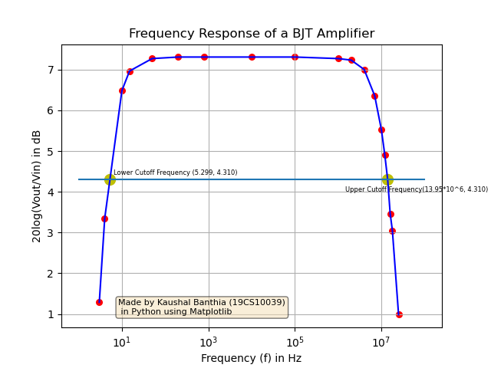

1. $R_{L}$ Disconnected

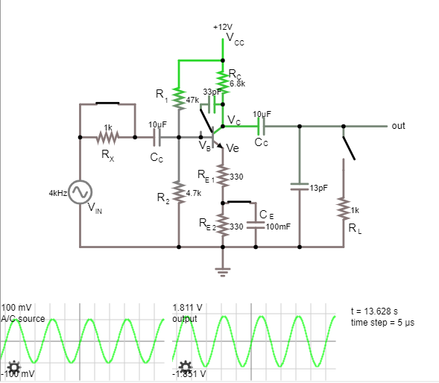

**CIRCUIT 6**

|  |  |  |  |
| --- | --- | --- | --- |
| $$V_{in}$$ (in V) | $$V_{out}$$ (in V) | Frequency  (in Hz) | $$20*log⁡(\frac{V_{out}}{V_{in}})$$ (in dB) |
| 0.1 | 0.442 | 1 | 12.908 |
| 0.1 | 0.802 | 2 | 18.083 |
| 0.1 | 1.077 | 3 | 20.644 |
| 0.1 | 1.271 | 4 | 22.083 |
| 0.1 | 1.676 | 10 | 24.485 |
| 0.1 | 1.746 | 15 | 24.841 |
| 0.1 | 1.804 | 50 | 25.145 |
| 0.1 | 1.809 | 200 | 25.149 |
| 0.1 | 1.810 | 800 | 25.154 |
| 0.1 | 1.806 | 10k | 25.134 |
| 0.1 | 1.806 | 100k | 25.134 |
| 0.1 | 1.586 | 1M | 24.006 |
| 0.1 | 1.217 | 2M | 21.706 |
| 0.1 | 0.747 | 4M | 17.466 |
| 0.1 | 0.452 | 7M | 13.103 |
| 0.1 | 0.320 | 10M | 10.103 |

The maximum value of the ratio $20*log⁡(\frac{V_{out}}{V_{in}})$ is 25.154 dB. Thus, we know that the lower and the upper cut-off frequencies are the one that have the ratio equal to a value of 25.154 – 3 = 22.154 dB.

By marking it on the graph, we can see that these frequencies are

4.110 Hz and 1.74 MHz respectively.

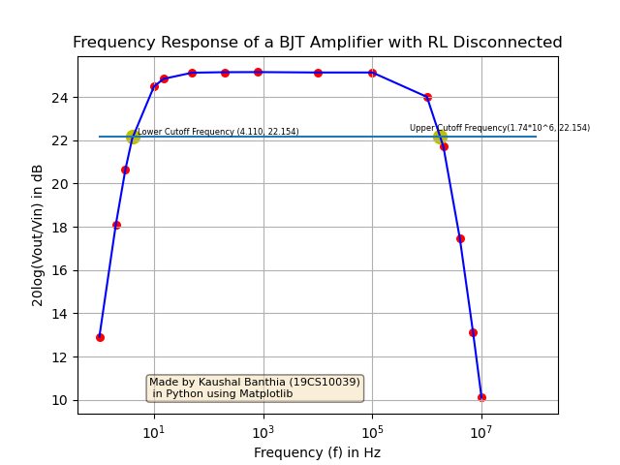

**Conclusion:**

When $R_{L}$ is connected, we see a lower gain (and thus a lower peak in the response) and when $R_{L}$ is disconnected ( $∞$ resistance), we see a higher gain (and thus a higher peak in the response).

This is because, Output Voltage is $V_{out}=I_{C}*R$ , where R is the parallel combination of all the resistances that are attached between the collector and the ground, that are not bypassed by any capacitors. (In the small signal AC circuit)

In our circuit, we have 2 such resistors, namely, $R_{L}$ and $R_{c}$. Thus, $R=R_{L}||R_{c}$

$$R=\frac{R_{L}*R_{c}}{R_{L}+R_{c}}$$

By taking a rough estimate of $R_{c}≫ R_{L}$, we get, $R≈R_{L}$ (even though $R_{c}$ is only 6.8 times $R_{L}$, we can assume $R_{c}≫ R_{L}$, just for the sake of getting an approximate result.

Since, now $R≈R_{L}$, we have ${V_{out}=I}_{C}*R_{L}$, which tells us that $V_{out}$ is directly proportional to $R_{L}$ (only until a certain limit though). Thus, if $R_{L}$ increases we see an increase in $V_{out}$ too and if $R_{L}$ decreases then $V_{out}$ decreases too.

When $R_{c}≈R_{L}$, then the proportionality doesn’t work and then we get just and increasing relation of $V_{out}$ with $R_{L}$. When $R_{L}$ becomes infinite (load is disconnected, then R becomes equal to $R_{c}$.)

$C_{E}$ Disconnected

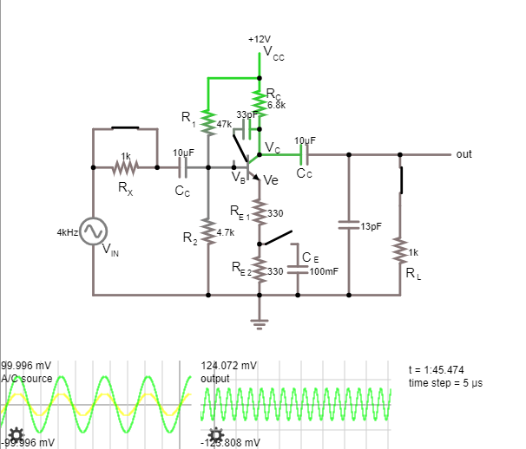

**CIRCUIT 7**

|  |  |  |  |
| --- | --- | --- | --- |
| $$V_{in}$$ (in V) | $$V_{out}$$ (in V) | Frequency  (in Hz) | $$20*log⁡(\frac{V_{out}}{V_{in}})$$ (in dB) |
| 0.1 | 0.107 | 7 | 0.588 |
| 0.1 | 0.113 | 10 | 1.062 |
| 0.1 | 0.118 | 15 | 1.438 |
| 0.1 | 0.123 | 50 | 1.798 |
| 0.1 | 0.124 | 200 | 1.868 |
| 0.1 | 0.124 | 800 | 1.868 |
| 0.1 | 0.124 | 10k | 1.868 |
| 0.1 | 0.124 | 100k | 1.868 |
| 0.1 | 0.123 | 1M | 1.798 |
| 0.1 | 0.121 | 2M | 1.656 |
| 0.1 | 0.113 | 4M | 1.062 |
| 0.1 | 0.110 | 7M | 0.828 |
| 0.1 | 0.101 | 10M | 0.086 |

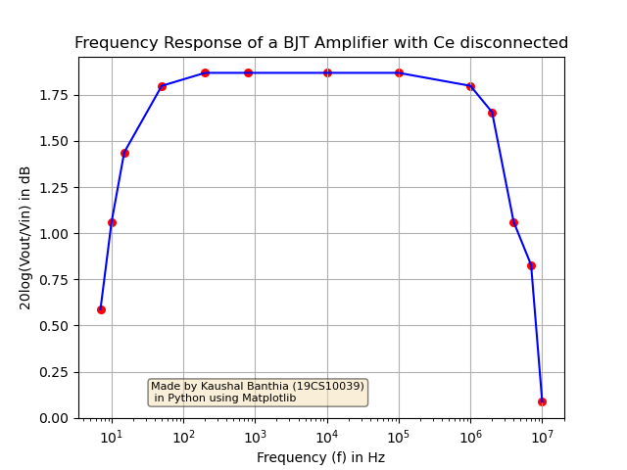

Now we connect $C_{E}$ to the emitter, thus bypassing all the emitter resistance. So, effectively we have, $R_{E}=0$.

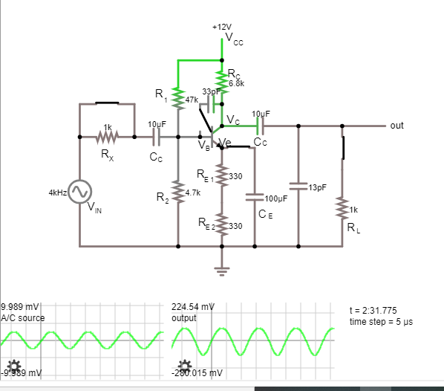

**CIRCUIT 8**

|  |  |  |  |
| --- | --- | --- | --- |
| $$V_{in}$$ (in V) | $$V_{out}$$ (in V) | Frequency  (in Hz) | $$20*log⁡(\frac{V_{out}}{V_{in}})$$ (in dB) |
| 0.01 | 0.0293 | 7 | 9.337 |
| 0.01 | 0.0434 | 10 | 12.750 |
| 0.01 | 0.0652 | 15 | 16.285 |
| 0.01 | 0.160 | 50 | 24.082 |
| 0.01 | 0.208 | 200 | 26.361 |
| 0.01 | 0.214 | 800 | 26.608 |
| 0.01 | 0.214 | 10k | 26.608 |
| 0.01 | 0.214 | 100k | 26.608 |
| 0.01 | 0.214 | 1M | 26.608 |
| 0.01 | 0.211 | 2M | 26.486 |
| 0.01 | 0.202 | 4M | 26.107 |
| 0.01 | 0.195 | 7M | 25.801 |
| 0.01 | 0.180 | 10M | 25.105 |
| 0.01 | 0.156 | 14M | 23.862 |
| 0.01 | 0.138 | 18M | 22.798 |
| 0.01 | 0.109 | 25M | 20.749 |
| 0.01 | 0.076 | 40M | 17.616 |
| 0.01 | 0.063 | 50M | 15.987 |
| 0.01 | 0.058 | 55M | 15.269 |

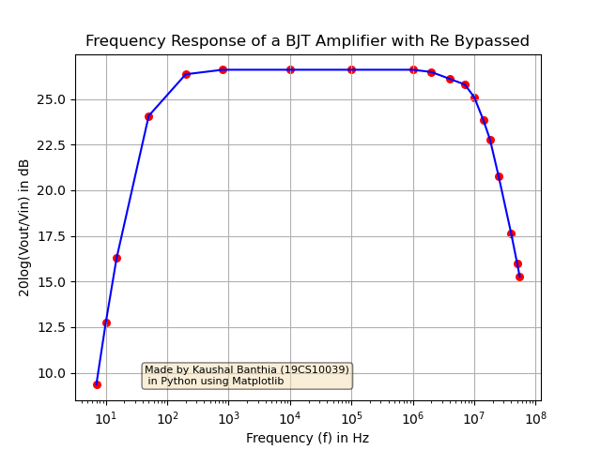

**Conclusion:**

When $C_{E}$ is disconnected, the total emitter resistance increases and hence the gain goes down, thus giving a lower peak in this response, than if $C_{E}$ were connected.

Now, we connect $C_{E}$ to the emitter of the BJT, bypassing all of the emitter resistance. So, effectively we have, $R_{E}=0$.

Since, all the emitter resistance is bypassed, i.e., $R_{E}=0$, the gain increases, thus giving a very high peak in this response, than if there was some emitter resistance present.

1. Miller Effect
2. Miller Capacitance Attached

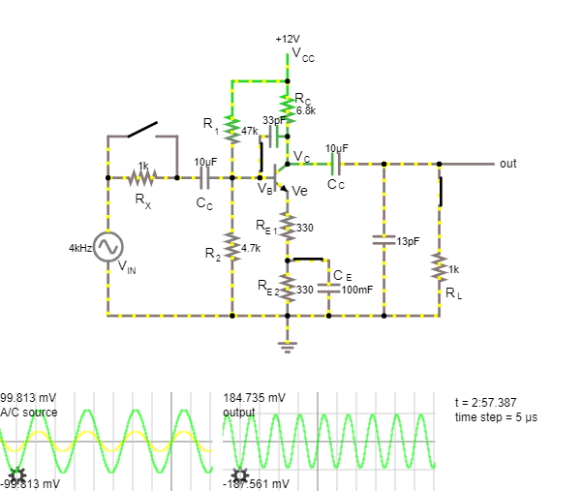

**CIRCUIT 9**

|  |  |  |  |
| --- | --- | --- | --- |
| $$V_{in}$$ (in V) | $$V_{out}$$ (in V) | Frequency  (in Hz) | $$20*log⁡(\frac{V_{out}}{V_{in}})$$ (in dB) |
| 0.1 | 0.104 | 3 | 0.341 |
| 0.1 | 0.161 | 7 | 4.137 |
| 0.1 | 0.172 | 10 | 4.711 |
| 0.1 | 0.179 | 15 | 5.057 |
| 0.1 | 0.185 | 50 | 5.343 |
| 0.1 | 0.185 | 200 | 5.343 |
| 0.1 | 0.185 | 800 | 5.343 |
| 0.1 | 0.184 | 10k | 5.296 |
| 0.1 | 0.183 | 100k | 5.249 |
| 0.1 | 0.160 | 750k | 4.082 |
| 0.1 | 0.146 | 1M | 3.287 |
| 0.1 | 0.100 | 2M | 0 |

The maximum value of the ratio $20*log⁡(\frac{V_{out}}{V_{in}})$ is 5.343 dB. Thus, we know that the lower and the upper cut-off frequencies are the one that have the ratio equal to a value of 5.343 – 3 = 2.343 dB.

By marking it on the graph, we can see that these frequencies are

4.960 Hz and 1.22 MHz respectively.

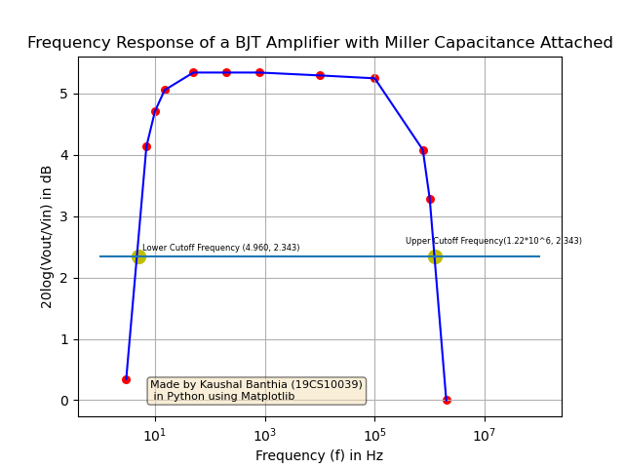

1. Miller Capacitance not Attached

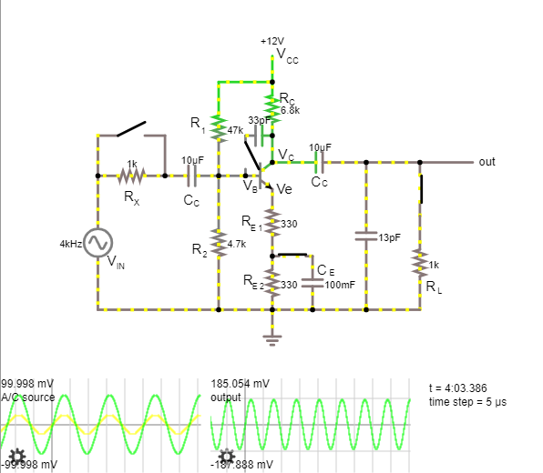

**CIRCUIT 10**

|  |  |  |  |
| --- | --- | --- | --- |
| $$V_{in}$$ (in V) | $$V_{out}$$ (in V) | Frequency  (in Hz) | $$20*log⁡(\frac{V_{out}}{V_{in}})$$ (in dB) |
| 0.1 | 0.104 | 3 | 0.341 |
| 0.1 | 0.161 | 7 | 4.137 |
| 0.1 | 0.172 | 10 | 4.711 |
| 0.1 | 0.179 | 15 | 5.057 |
| 0.1 | 0.185 | 50 | 5.343 |
| 0.1 | 0.185 | 200 | 5.343 |
| 0.1 | 0.185 | 800 | 5.343 |
| 0.1 | 0.185 | 10k | 5.343 |
| 0.1 | 0.185 | 100k | 5.343 |
| 0.1 | 0.185 | 750k | 5.343 |
| 0.1 | 0.185 | 1M | 5.343 |
| 0.1 | 0.177 | 5M | 4.959 |
| 0.1 | 0.156 | 10M | 3.862 |
| 0.1 | 0.133 | 15M | 2.477 |
| 0.1 | 0.120 | 20M | 1.584 |

The maximum value of the ratio $20*log⁡(\frac{V_{out}}{V_{in}})$ is 5.343 dB. Thus, we know that the lower and the upper cut-off frequencies are the one that have the ratio equal to a value of 5.343 – 3 = 2.343 dB.

By marking it on the graph, we can see that these frequencies are

4.691 Hz and 15.66 MHz respectively.

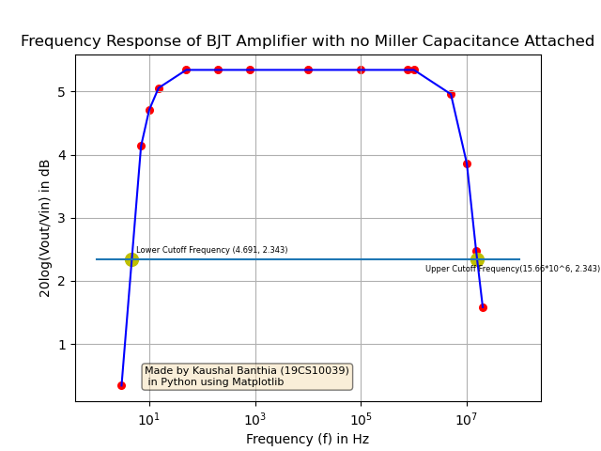

**Conclusion:**

From the above two graphs we can observe that if the Miller Capacitance is added, then it acts as a Parasitic Capacitor, which leads to the decrease of the output voltage at high frequency. Now, if the Miller Resistance is not attached, then we can see that the response has an output voltage for much longer than before (much higher frequencies also give an output voltage). This is because now this miller capacitance does not cause the decrease and thus the frequency response goes on longer, before being brought down by the other parasitic capacitances.

1. Measurement of Input Resistance in Mid-Frequency Range:

$$V_{in}=0.1 V, { I}_{in, R_{x}}=20.7 μA, { R}_{x}=1kΩ, { V}_{out|R_{x}}=1.444 V, { V}_{out|0}=1.805$$

Measured from Falstad:

$$R_{in}=\frac{V_{in}}{{ I}_{in, R_{x}}}-R_{x}$$

$$R_{in}=(\frac{0.1}{20.7*{10}^{-6}}-1000) Ω$$

$$R_{in}=\left(4830.92-1000\right) Ω$$

$$R_{in}=3830.92 Ω$$

Calculations based on Manual:

$$R_{in}=\frac{R_{x}*V_{out|R_{x}}}{V_{out|0}-V_{out|R_{x}}}-R_{s}$$

$$R_{in}=(\frac{1000*1.444}{1.805-1.444}-0) Ω$$

(Assuming $R_{s}=0$)

$$R_{in}=4000 Ω$$

Now, if take difference of these values, we get a finite resistance, which we can attribute to $R_{s}$

Thus,

$$R_{s}=R_{in, manual}-R_{in, falstad}$$

$$R_{s}=\left(4000-3830.92\right)Ω$$

$$R_{s}=169.08 Ω$$

1. Measurement of Output Resistance in Mid-Frequency Range:

$$R_{c}=6.8kΩ, { V}_{out|∞}=1.81 V, { V}_{out|R_{L}}=0.232 V, { R}_{L}=1 kΩ$$

Measured from Falstad:

$$R_{out}=R_{c}$$

$$R_{out}=6800 Ω$$

Calculations based on Manual:

$$R_{out}=R_{L}*\frac{V_{out|∞}-V_{out|R_{L}}}{V_{out|R_{L}}}$$

$$R_{out}=1000*\frac{1.81-0.232}{0.232} Ω$$

$$R_{out}=1000*6.802 Ω$$

$$R_{out}=6802 Ω$$

The difference between the output resistances calculated using Falstad and the manual is negligible (2 $Ω$) and thus can be ignored as an error while approximation.